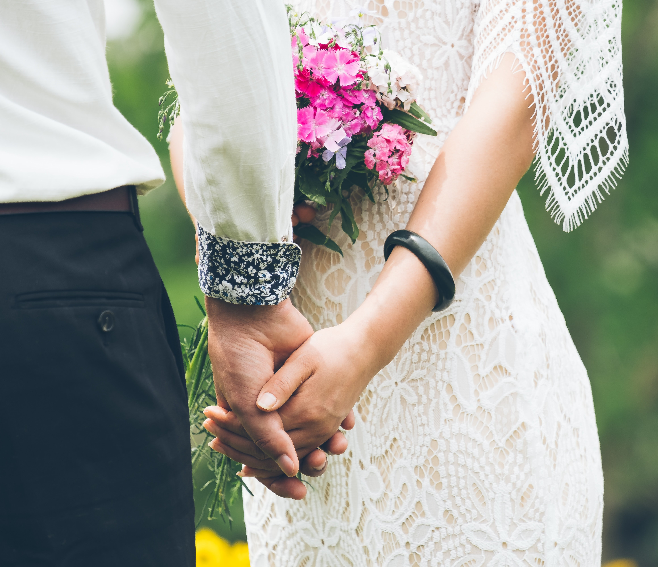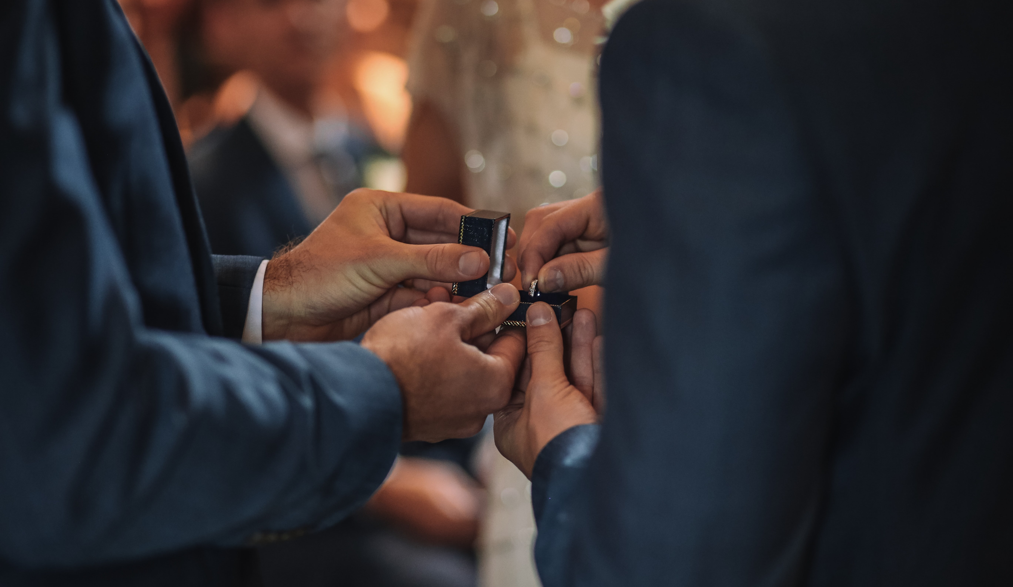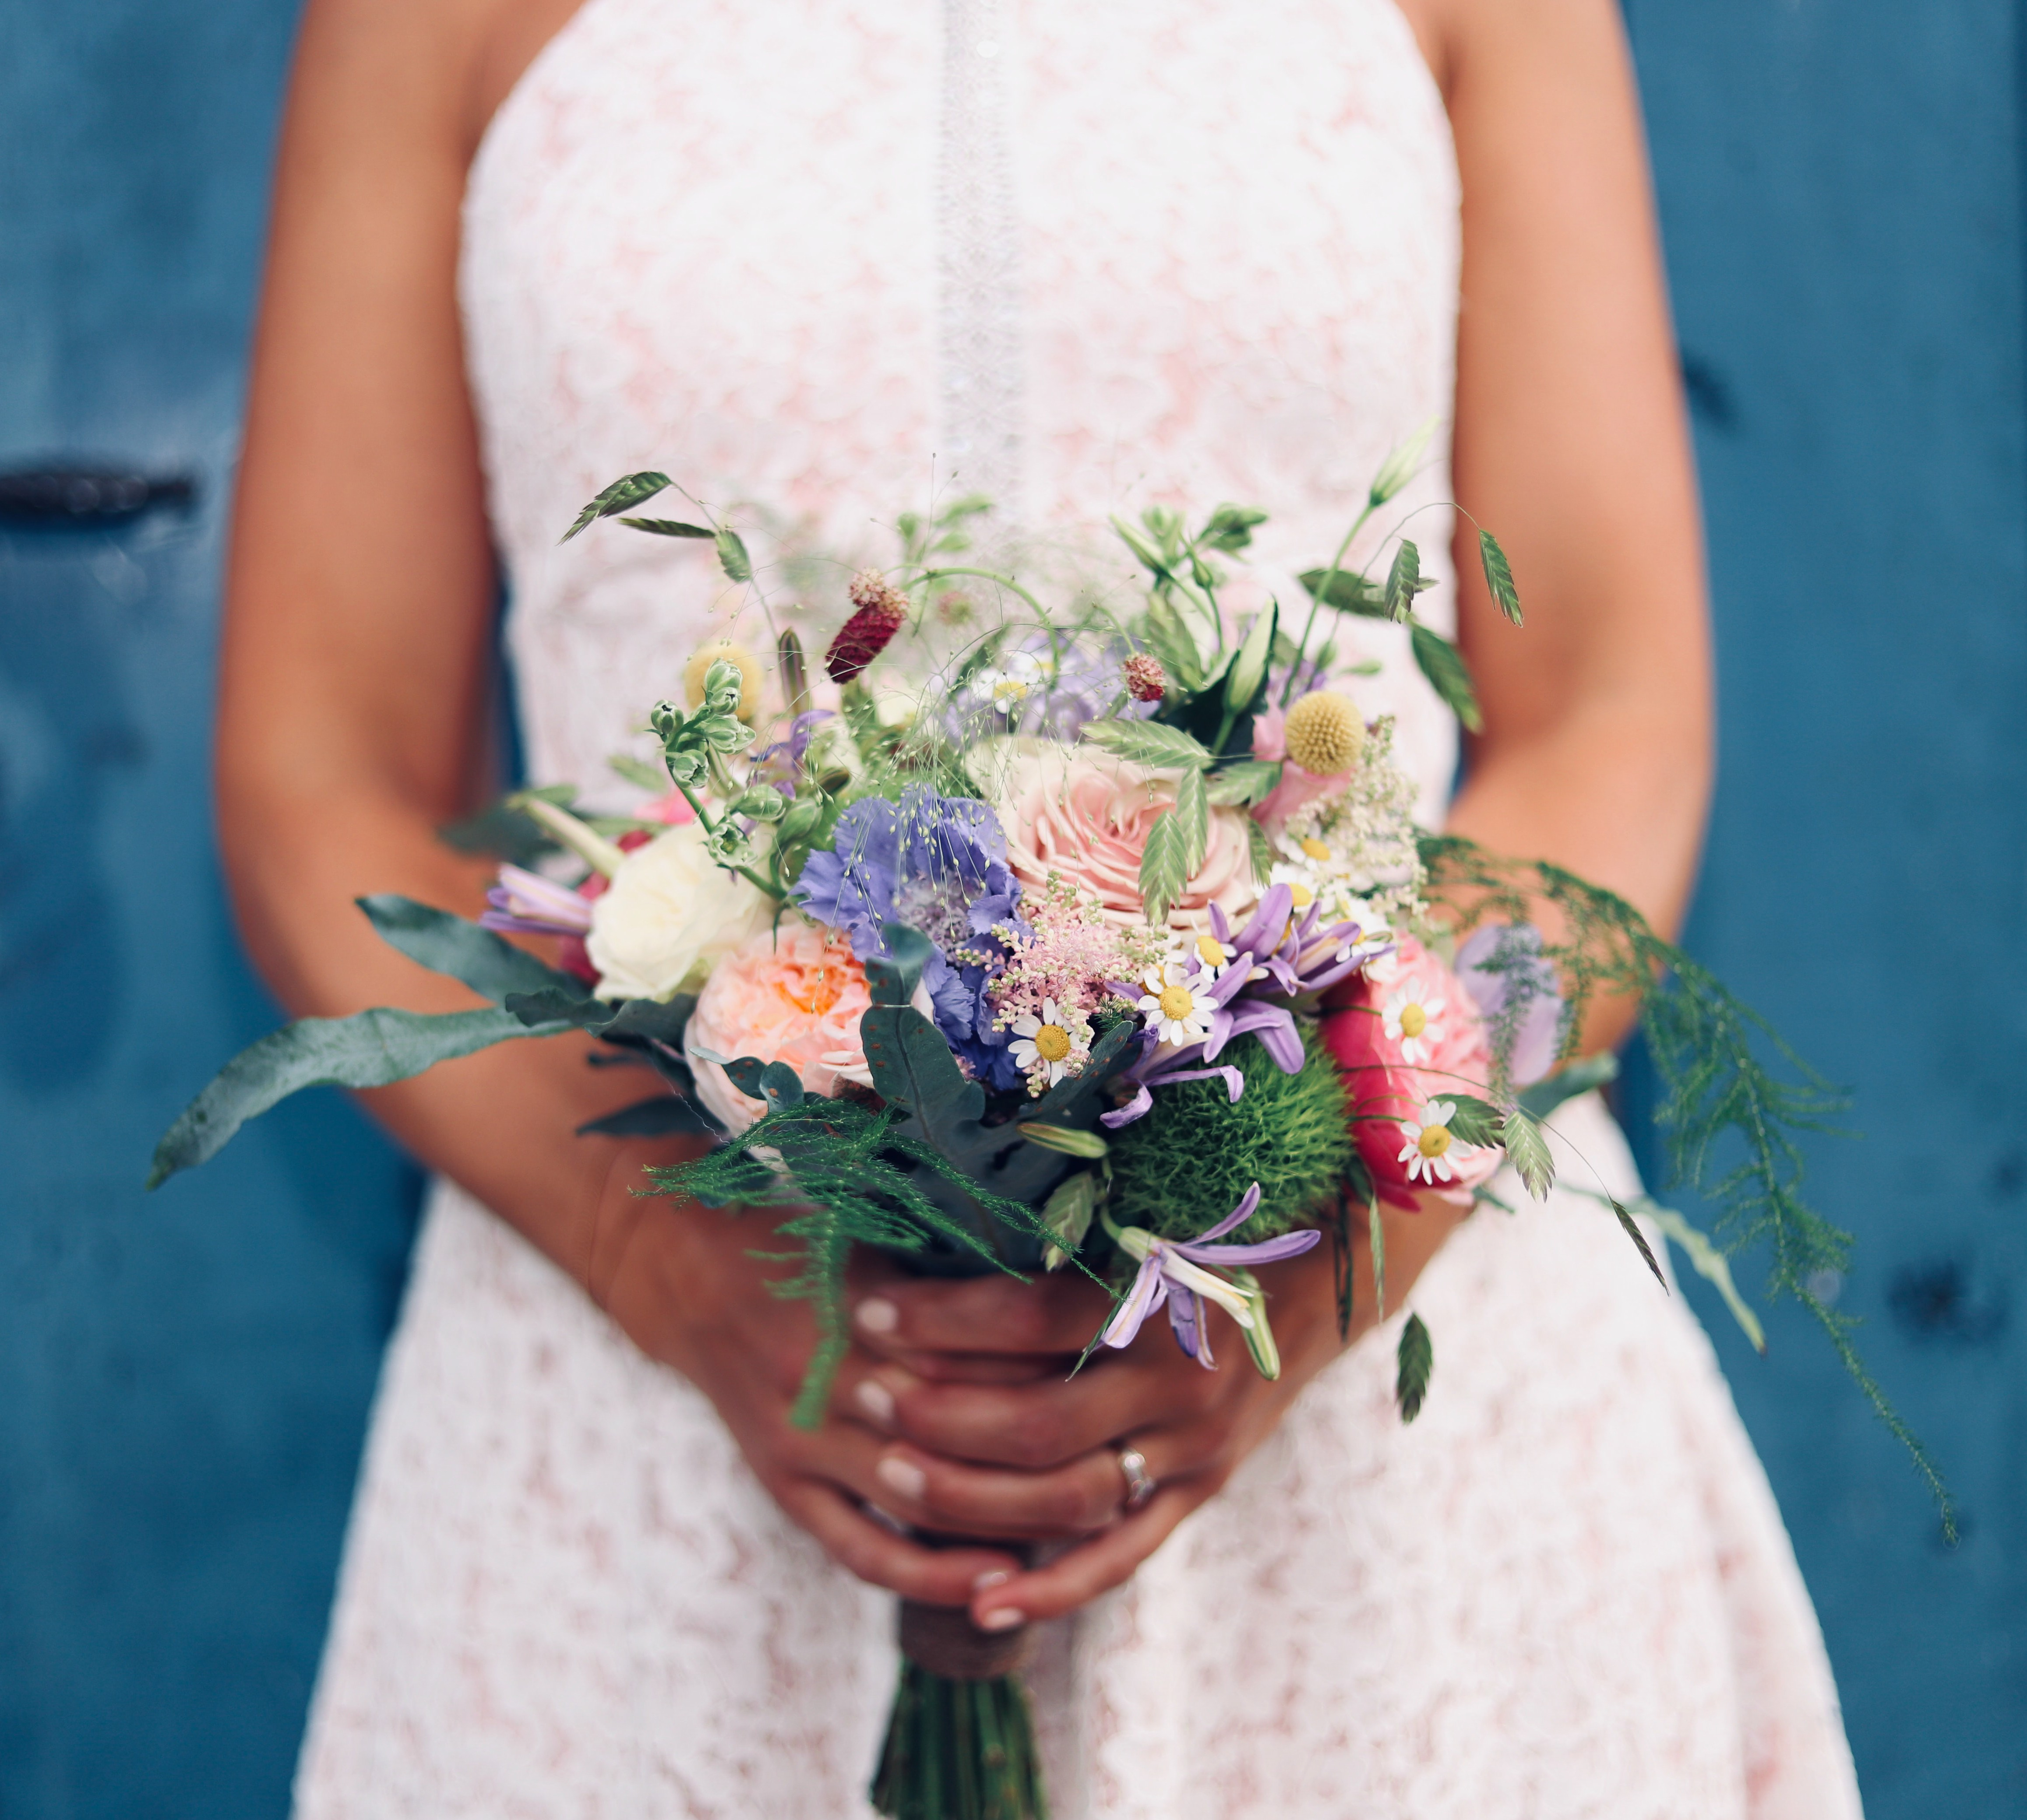

WIN WIN WIN WIN WIN WIN WIN
Free 3 course Wedding Breakfast for up to 40 people Please enter for a chance to win drawn October 2020

NAME...........................................................................................................

ADDRESS.....................................................................................................

EMAIL ADDRESS........................................................................................

TELEPHONE NO..........................................................................................
T&C'sapply
01524 32451 | royalkingsarmshotel.co.uk

Wedding Showcase Poster.indd 1 19/01/2020 19:37

